Pierre A. Maroun

December 12, 2019

US Government Reaction to 9/11 Attacks
Strategic Planning or Islamophobia?

INTRODUCTION
The relationship between the United States and some Muslim countries, mainly Afghanistan, was troubled after the 9/11 terrorist attacks on New York, and the Pentagon. However, despite the terror and anguish these attacks caused to the American people, the US managed to maintain good relationships, and to build alliances, with many Muslim countries such as Saudi Arabia, Kuwait, United Arab Emirates, Pakistan, and others. In fact, these numerous Muslim countries became the backbone of the US-led war on international terrorism. Furthermore, the US established military cooperation and training programs with some Muslim countries, like the Kingdom of Jordan, Egypt, and Iraq, after deposing the late Saddam Hussein, and other countries, which joined the international military coalition to fight Islamist groups such as Al Qaeda, ISIS, AL-Nusra, or Al-Shabab, and others. Meanwhile, at home, the US military and security agencies have received the help of many American Muslims who joined the military and the various law enforcement agencies in order to help defend the homeland against terrorists.
On the other hand, however, sporadic anti-Muslims attacks spread across the US after the 9/11 attacks. Accordingly, while we believe that these attacks were committed by few angry Americans in retaliations to the terrorist attacks, others believe that Americans were driven by Islamophobia. For example, in his book, American Islamophobia: Understanding the Roots and Rise of Fear, renowned scholar, Khaled Beydoun, charges that the post 9/11 attacks against American Muslims were committed by American Islamophobes. Furthermore, he claims that Islamophobia is entrenched in American society, and that the US counterterrorism laws and policies, which were passed after the 9/11 attacks are Islamophobic. We tend to disagree, especially since we believe that the majority of the American people are tolerant and accepting of others, while the Islamophobes are the exceptions. Therefore, in order to contest Beydoun’s charges, this research paper intends to examine his claims and theory, and it will attempt to provide counterarguments to Beydoun’s various charges of Islamophobia against Americans, and their institutions.
Beydoun starts his book with a sad story about three young Muslim American students who were killed by their Islamophobe neighbor, who claimed to have killed them over a parking lot dispute. However, according to Beydoun, evidence reveals that it was a hate crime. He believes that had it not been for Islamophobia, these three students would still be alive. Furthermore, Beydoun relies throughout his book on appalling attacks by Americans against Muslim Americans, and non-Muslim Americans, to paint the whole US population as Islamophobic. For example, he mentions the case of Balbir Singh Sodhi, an Indian American Sikh, who was killed because a criminal thought that he was a Muslim.
Thus, while these attacks are horrible, inexcusable, and must be dealt with as hate crimes, they are, however, the exceptions in American culture. However, Beydoun depicts them as the reflective of deeper norm or culture since he believes that Americans are Islamophobes. Basically, Beydoun’s generalization about the Americans is similar to what he accuses the Americans of doing to Muslims, which is depicting them all as terrorists-both are wrong. Therefore, while there is no excuse, or justification to randomly attack Muslims, or non-Muslims, it is however, misleading and wrong to simplify the problem of Islamophobia, and to generalize about the American population.
ISLAMOPHOBIA
Beydoun defines Islamophobia “as the presumption that Islam is violent, inassimilable, and prone to terrorism. That presumption,” he affirms, “is evidently driven by state law and policy.” Furthermore, Beydoun believes that “it is state law and policy that is directing and disseminating these negative tropes” through media to the public, and that the “fundamental trope is tying Muslim identity to the possibility for terrorism.” Accordingly, Beydoun divides Islamophobia into three dimensions: structural Islamophobia, private Islamophobia, and dialectical Islamophobia.
STRUCTURAL ISLAMOPHOBIA
According to Beydoun, structural Islamophobia is “basically how state policy like the Patriot Act, NSEERS, Countering Violent Extremism, the travel bans, even the ‘”See Something, Say Something’” campaign, are all central to advancing the war on terror, are built upon the foundational presumption that ties Muslim identity to the possibility of homegrown radicalization.” Furthermore, Beydoun affirms that “Islamophobia is embedded within the institutional memory of government agencies, including the judiciary, the legislature, and the executive branch-most notably the Department of Homeland security and anti-terror law enforcement during the protracted war on terror.” He adds, “Such policies assign the presumption of guilt to Muslims at large, and in turn diminish the civil liberties of Muslim Americans.” Furthermore, Beydoun goes further to charge that Islamophobia is the modern method of Orientalism, and that the “architects of the US adopted wholesale the Orientalist worldview and its attendant representations and misrepresentations.”
Remarkably, Beydoun bluntly states that his definition of Islamophobia “frames the state as a potent collaborator that influences and (periodically) drives the acts of individual hatemongers, or Islamophobes, making it complicit in the range of hate crimes and hate incidents targeting Muslim individuals and institutions.” While Beydoun’s allegations are very serious, he provides no evidence of clear Islamophobic comments or statements of US officials involved in passing the state’s laws and policies. Instead, he only relies on his suspicious interpretations of the state’s intentions of passing these laws. In fact, Beydoun quotes a speech, which President George W. Bush, delivered two weeks after the 9/11 attack, in which the President ‘“addressed Muslims and American Muslims directly, claiming,
‘” We respect your faith. It’s practiced by millions of Americans, and by millions more in countries that America counts as friends. Its teachings are good and peaceful, and those who commit evil in the name of Allah blaspheme the name of Allah. The enemy of America is not our many Muslim friends…our enemy is a radical network of terrorists.”’ However, Beydoun ignores President Bush’s positive reach out to Muslims completely. Instead, he claims that the President’s “war on terrorism overshadowed his peaceful appeal to Muslims.”

Beydoun possibly ignores the speech since its content does not support his charge of structural Islamophobia, or that of US politicians being bigots. However, others seem to give credit to the President’s good gesture. According to Mahmoud Mamdani, author of “Good Muslim, Bad Muslim: A Political Perspective on Culture and Terrorism,” a week after the attacks of 9/11, President George W. Bush and British Prime Minister, Tony Blair, “were at pains to confirm aloud that theirs was a war not against Islam, nor even just Islamic terror, but against terrorism. Accordingly, it is fair to assume that President Bush’s speech may have eased tensions among Americans, which in turn may have saved lives. Therefore, to disregard by Beydoun it is wrong.
Moreover, investigating the state’s laws and policies reveals that for decades, the state has been taking the necessary measures to combat threat of terrorism, which is the “systematic use of terror especially as a means of coercion.” Furthermore, the state has been firmly working to eliminate threats facing the nation without singling out one group or another and regardless of who the terrorists may be.
According to the FBI website, the state’s federal law enforcement agency’s mission and definition of terrorism is divided into domestic and international terrorism. It defines “international terrorism as the acts “perpetrated by individuals and/or groups inspired by or associated with designated foreign terrorist organizations or nations.” Moreover, as for the example of international terrorism, the FBI uses the shooting in San Bernardino, CA, December 2, 2015, which killed 14 people and wounded 22, and which was committed by a Muslim married couple who were inspired by Muslim extremist ideologies and foreign terrorist organizations to attack non-Muslim Americans. Notwithstanding, the FBI does not mention the couple’s Muslim religious affiliation in its definition of international terrorism, which is an indication that the FBI is not targeting Muslim terrorists only, but all terrorists.
The FBI defines domestic terrorism as the acts “perpetrated by individuals and/or groups inspired by or associated with primarily U.S.-based movements that espouse extremist ideologies of a political, religious, social, racial, or environmental nature.” The FBI uses the June 8, 2014 Las Vegas shooting, during which two police officers inside a restaurant were killed in an ambush-style attack, which was committed by a married couple who “held anti-government views and who intended to use the shooting to start a revolution.” Additionally, the FBI considers that the current threat to the US is still the traditional threat posed by AL-Qaeda. However, it states that “threat of domestic terrorism also remains persistent overall, with actors crossing the line from First Amendment protected rights to committing crimes to further their political agenda.” Evidently, the FBI does not refer to any specific religion when defining terrorism, or in the examples it provides to explain the difference between domestic and international terrorism.
Moreover, according to the Department of Justice (DOJ) website regarding the USA PATRIOT Act, the US Congress has simply altered some existing laws in order to be used for counterterrorism investigations. Thus, the website of the Department of Justice states that, “while the results have been important, in passing the Patriot Act, Congress provided for only modest, incremental changes in the law.” It allege that “Congress simply took existing legal principles and retrofitted them to preserve the lives and liberty of the American people from the challenges posed by a global terrorist network.” Furthermore, the DOJ post continues, “Since its passage following the September 11, 2001 attacks, the PATRIOT Act has played a key part - and often the leading role - in a number of successful operations to protect innocent Americans from the deadly plans of terrorists dedicated to destroying America and our way of life.”
Notwithstanding, the FBI has been gathering domestic intelligence since the 1930s, and during World War II, the FBI's duties was extended to “investigation of possible espionage, sabotage, or subversion.” Therefore, the US government did not need to pass new laws to combat terrorism since the above mentioned ones, and existing laws, which were used to combat criminal activities, and which were used for criminal investigations, were solid tools to also combat counterterrorist activities. Accordingly, to better understand the failure of the state security agencies, and to analyze whether new laws to investigate counterterrorism crimes was needed after the attacks of 9/11, there was a need for a thorough investigation.
Therefore, in 2004 investigative report, the “Legal Barriers to Information Sharing: The Erection of a Wall Between Intelligence and Law Enforcement Investigations,” Commission on Terrorist Attacks Upon the United States, which was directed by Senior Counsel for Special Projects, Barbara A. Grewe, revealed that:
At the time leading to the 9/11 attacks, the FBI had the means to conduct criminal and intelligence investigations and surveillance. However, it has different venues to conduct each responsibility separately. For criminal investigation, the FBI used the traditional criminal method to obtain warrants, whereas for foreign intelligence investigations and surveillance, the FBI applied for a warrant through the FISA court.

Furthermore, the report discovered that the FBI has created a “wall” between its criminal investigation division and its intelligence and surveillance division. Hence, the Commission concluded that it was not legal barriers, which have prevented the sharing of information among agencies, and within the FBI. Rather, it was a failure on the part of the “agents” who did not understand the laws available to them at the time leading to the 9/11 attacks.
Accordingly, it is clear that the Commission, which also investigated the failure of the numerous US Law enforcement and Intelligence Agencies to communicate and share information aptly and vigorously in order to detect, investigate, prosecute, and prevent the terrorist attacks of September 11, 2001, concluded that there was no need for new laws, and it suggested that Federal Agents should be trained to be familiarized with current laws and tools in order to conduct better investigations. Thus, to suggest that existing laws were based on Islamophobia is sheer allegations by Beydoun. Nevertheless, according to Dr. Jacob Labendz, it must be noted that while the laws may not be Islamophobic, their application and reassessment might be, especially the surveillance of Mosques and the “See something, Say something” policy and many other policies.
Dr. Labendz concerns have merit, especially since not all agents are properly trained, and some may be Islamophobes or racist. However, it must be also noted that the responsibility of applying state laws in racist manners shall fall on the shoulders of the individual agents who misuse the procedures, not on the laws passed by the state. Furthermore, not to justify abuse of process, and not to excuse racism, but sometimes desperate times require the state to take drastic measures in order to protect citizens. However, this protection is a delicate balance between securing the community and preserving civil liberties, and the former shall not be at the expense of the latter, or at the expense of terrifying any portion of society. However, it seems that Beydoun is using Islamophobia as a weapon to silence critics and to oppose state laws and policies, which are meant to preserve peace and stability in the country.
PRIVATE ISLAMOPHOBIA
In addition, Beydoun defines “private Islamophobia” as the form, which widely covers and monopolizes broader definitions of Islamophobia, “looks primarily at what private individuals are doing with regard to attacking, targeting, and holding specific negative ideas of Muslims.” He adds, “We see this through the uptick in hate crimes, attacks on conspicuous or visible Muslims.” Accordingly, Beydoun charges that islamophobia is an American problem, which is entrenched in US society.
However, Beydoun does not attempt to explore the possibility that some American individuals may be angry with terrorist attacks, and that their anger is not based on Orientalism, Islamophobia, and or racism, but rather on fear of being killed by these random attacks. This is by no means excusing or justifying any attacks on innocent Muslims or non-Muslims. However, Beydoun does not seem to believe that only few rotten apples do not make the entire box rotten. Therefore, it seems that one more time Beydoun is using Islamophobia as a weapon to compromise the American society.
Accordingly, in order to refute Beydoun’s allegations, one must understand the American people’s suspicion and anger of some, if not all, Muslims. Therefore, this research will look back into the 20th century, where many incidents, which were conducted by some Muslims caused harm to the American people, and to the US interests at home and abroad. Thus, in his book, Islamophobia and Racism in America, Erik Love, believes that Islamophobia is structural, systematic, and institutional. However, unlike Beydoun, Love believes that “Islamophobia is best understood as a racist project, one that distributes resources in service of maintaining the race-based subordination of marginalized groups.” However, though it is about foreign Muslims not American ones, Love explains the reasons behind the suspicions, which exists between non-Muslims and Muslims in general. For example, Love assets that the Arab-Israeli war of 1967 (Six Day War) where Israel defeated the armies of Egypt, Jordan, and Syria helped depict in American the idea of a ‘dangerous Middle East,’ and that Arabs are fanatics. It also set the idea of the “clash of civilizations” between the West and its allies, including Israel, against the dangerous and violent Middle East. Accordingly, he points out that it was alright in “polite company in America to make blatantly ignorant and bigoted statements about Arabs and Muslims, and because of such rhetoric, the term “Middle Eastern,” “Arab,” and “Muslim” refers to the same ascribed racial identity today.
Furthermore, Love also mentions the “Oil sheiks” decision, which caused the oil crisis of the 1973, which crippled an already weak economy, and the 1979 Islamic Revolution in Iran and the hostage crisis of the US embassy. In addition, he refers to the several anti-American terrorist attack i.e. the bombing of the Marine barracks in Beirut in 1983, and the Libyan bombing of the PAN 103 flight over Lockerby, Scotland, the hijacking of an American cruise ship by the Palestinians, and many other attacks made the term “terrorist” synonymous with Arabs in the 1970s and 1980s.
In addition, prior to 2001, there was a barrage of radical Muslims attacks against US civilians, servicemen, and interests around the world. For example, as Love mentions briefly, in 1983, a Muslim suicide bomber attacked the US embassy and the Marine’s headquarters in Beirut, in 1983, which killed 241 marines. Simultaneously, another suicide bomber attacked the French contingency’s base killing 58 paratroopers. These troops were part of the Multinational Force serving a peacekeeping mission in Lebanon, and they were not western invaders trying to occupy Muslim land. Thus, these examples provide many genuine reasons behind the Americans ill-sentiment and stereotyping of Arabs and Muslims prior to the attacks of 9/11.
Hence, not to excuse or to accept the crimes committed by few American bigots against non-participant Muslims, but intentionally or not, Love’s argument show that Americans have many reasons to be suspicious of Arabs, which as he affirms also means Muslims and Middle Easterners. Accordingly, the state has the right and the duty to pass effective laws and policies, which would combat and deter the apparent enemy, Islamists in this case, from striking against the US interests and its citizens. Beydoun refers to this repulsive reality as Islamophobic laws and policies adopted by Islamophobic American state. Notwithstanding, while the US politics and policies may have created an uneasy condition for Muslims, or non-Muslims minorities, terrorism cannot be used by radicals to coerce the state to change its policies. In a democratic republic, the majority rules through elections, while the civil liberties of all people must be preserved.
However, this is by no means suggesting that Muslims in general, including American Muslims, do not have reasons to fear or to dislike the US, or to not be suspicious of its actions, laws, and policies. In his article, “Islamophobia and the Roots of the Muslims Anger,” Bernard Lewis sheds light on the long history between the west, or Christendom, and Islam. Furthermore, he attempts to explain the reasons behind some Muslims’ anger and hate for the West, and the US. Accordingly, Lewis explores all the possible “offences and sins,” which the US may have committed against Muslims throughout history, which could have caused this anger. He discusses racism, antisemitism, sexism, the treatment of women, Nazism and Communism propaganda, the support for Israel, and Imperialism. While Lewis focusses more attention on Imperialism, he still couldn’t rational that it is an offense, which is grave enough to generate such great anger. Ultimately, he concludes that Muslims are angry because they are weak and humiliated, while the west is powerful and thriving.
While Lewis places all Muslims in one basket, or category, it is important to note that Muslims come from different countries with different cultures, and that they have different worldviews. Therefore, they react differently to world events and they even have different interpretations of Islam and the versus of the Quran. However, Lewis’ theory regarding Muslims’ anger still stands, but varies in degree or level of anger, and in their methods of reactions, whereas the moderates may oppose the US peacefully, while the radicals may resort to violence. Moreover, it is worth mentioning that Lewis’ claims are opposed by many scholars to the extent that some even accused him of being an Islamophobe himself.
However, regardless of Lewis’ sentiments vis-a-vis Islam and Muslims, his critics’ accusations are inappropriate for they shut down dialogue regarding Islam, terrorism, and Islamophobia. In his book, ”’Islamophobia’ Reconsidered,” Fred Halliday argues that the “use of the term ‘Islamophobia’ challenges the possibility of dialogue based on universal principles,” which suggests that the “solution lies in greater dialogue, bridge-building, respect for the other community.” However, he adds, referring to criticism of Islam as Islamophobia “inevitably runs the risk of denying the right, or possibility, of criticism of the practices of those with whom one is having the dialogue.” Therefore, Halliday affirms, those who “challenge conservative readings from within, can more easily be classed as Islamophobes,” adding that “’Islamophobia,’ like its predecessor ‘imperialism,’ can easily be used to silence critics of national states and elites.” Evidently, Halliday is warnings applies to Beydoun, who is probably trying to silence critics of Islam and radical Muslims, which in turn is hindering dialogue and peaceful resolution.
Furthermore, another issue, which is a widespread phenomenon in the Muslim world, and which is a cause for some Muslims’ anger with the US and its allies is the “Conspiracy Theory.” Thus, there is a general belief in the Middle East that the Zionists/Mossad and the US/CIA are responsible for everything harmful, which happens to Muslims. For example, there is a strong belief amongst Muslims that the Israeli Mossad and the CIA, not AL Qaeda, perpetrated the 9/11 attacks. The reason? They wanted to implicate Muslims in order to provide a premise for the west to invade Iraq, Afghanistan, and other Muslim countries.
Likewise, many Afghanis and Muslims believe that the US and the Taliban are working together and that they are collaborating on many issues, since the US has been “using Afghanistan “just as a barracks against Iran, against Pakistan, against China, against Russians.” Moreover, while the US presence in Afghanistan may have some merit to it, other Middle Eastern journalists, or conspiratorialists, believe that “it was none other than Mossad agents who were behind the attacks on the World Trade Center and the Pentagon. Mossad’s motive? To blacken the name of Arabs and Muslims in the United States and to enable Israel to have its way in Palestine.”
Accordingly, those radical Muslims who believe in conspiracy theories are constantly suspicious of US actions, and they are consistently adamant to fight all American policies, especially its foreign policy vis-à-vis the Arab-Israeli conflict, whereas the US provides utter support for Israel. Consequently, some Muslims, especially the radicals, may view such US policy as unjust and harmful to the Palestinian people. Therefore, they turn their anger against the US, which they consider the guarantor of Israel. Accordingly, for example, in his “Letter to America,” Usama Bin Laden referred to the US backing of Israel as one of the main reasons he was fighting the US.”
GENERALIZATION AND SIMPLIFICATION
Beydoun also believes that islamophobia is not limited to one political party or another, and that it stretches across the political spectrum from the alt-right groups to far left ones. Beydoun’s claim is inaccurate and quite wrong. According to a study conducted by the Pew Research Center (PRC), results shows that Republicans and those leaning toward the GOP “view Muslims far less positively than they view members of most other major religious groups. Furthermore, the study reveals that the U.S. public is split over whether there is a ‘”natural conflict’” between Islam and democracy, and it shows (Figure 2) which segments in American society are more likely to be Islamophobes. Thus, according to the PRC study, it is clear that the Jewish community, followed by the Hispanic community are far less likely to be Islamophobes than the Catholic and the Evangelical communities. Accordingly, this is another claim by Beydoun where he paints the whole population with one negative brush. Therefore, to state that Islamophobia stretches across party lines equally is inaccurate, unfair, and misleading.
Furthermore, Beydoun also claims that Islamophobia is entrenched in American society, which is also misleading. Firstly, it is important to note that the American people are known for their kindness, generosities, and for their acceptance of other nationalities regardless of race, religion, or culture, given that they are peaceful. Secondly, the US is one the most diverse nation state in the world. Its population is different culturally, racially, religiously, and economically. According to the census bureau, the minorities population in the US rose to 37.9% in 2014, and that the states of California, Texas, New Mexico, Hawaii, and the District of Washington, D.C. are now majority-minority, while they make 48.5% of Nevada. As for the 2018 census, the chart (Figure 9) shows that the minority communities are growing steadily. Therefore, for Beydoun to generalize about the whole US population is unfair, inaccurate, and misleading.
Furthermore, while few Americans may be Islamophobes, many studies and polls reveal that most Americans are tolerant people who are accepting of others. For example, an Arab News article and pool reveal that even Muslims believe that the American people are kind and accepting, and that they are not Islamophobes, and that for every bigoted politician and American Islamophobe, there are millions of silent Americans who are tolerant of all others, including Muslims and Islam. Furthermore, the article “While the media and the Islamophobes spewed poison against Muslims, a kinder, gentler side of North America emerged,” said a Californian resident, Sabra, to Arab News reporter. He also affirmed that on one ”occasion, over 250 Christians and Jews formed a circle around their mosque vowing to protect it from any attacks.”
Moreover, John, a man from Ohio, told Arab News, “I have met many Muslims and find them to be nice and friendly. I would say to them, like the terrorists are in minority, so are the Islamophobes. Just be patient.” He adds that “this is an election year; anti-Muslim sentiments are being fanned by the politicians. It will pass. Unfortunately,” he concludes, “We have a history of racism.” It must be noted that recognizing the problem is half the solution. Therefore, if Americans recognize that they have a history of racism, then it is more likely that the new generations will work on eliminating such problem.
As well, a comment by a reader using the username of Genie, affirms that "most Americans are not Islamophobes." She states that “there cannot be any truer statement than the foregoing. In fact,” she adds, “I would say that there are millions upon millions of hard working decent, caring and helpful Americans who have always been and are being ‘”defamed’” by the very minute minority of ugly and evil people living in America.” She concludes her statement by stating that, “Truth shall prevail eventually.” Thus, there is no reason to distrust the testimonies of these people. Unfortunately, some politicians use fear and uncertainties to attract the votes of the uninformed voters, while others use the bigoted speeches of such irresponsible politicians to charge Americans with Islamophobia.
Furthermore, according to a question asked by the PRC study regarding Americans’ attitudes towards Muslims, the results reveal that Americans believe that “there is little or no support for extremism among U.S. Muslims.” Moreover, the report adds that “there has been a decrease in the segment who believes that Islam is more likely than other religions to encourage violence among its followers.” In addition, the PRC study reveals (Figure 3) that there has been a remarkable increase in positive views and sentiments toward Muslims by Americans due to their better understanding of Muslims and Islam. For example, in December 2016, 49% of Americans believed Islam is not any more violent than any other religion and that it does not promote Islam violence among its followers, while 41% believed that it is more likely to encourage violence-a decline by 9% since September 2014.
In addition, the Institute for Social Policy and Understanding (ISPU) analysis reveals (Figure 5) that “knowing a Muslim personally is among several protective factors against Islamophobia.” Therefore, when a Muslim is a close friend, Islamophobia is further reduced. Moreover, the ISPU study finds (Figure 6) that three in four Jews know a Muslim, and about 50% of the general public know a Muslim.
Furthermore, since the above-cited data reveals that typical Americans are not Islamophobes, statics indicate that most anti-Muslim attacks which occur in the US are in reaction to Muslim terrorist attacks in the US or Europe. For example, studies conducted by the New America (Not to be confused with the New America Foundation), which is an independent non-profit organization that publishes anti-Muslim activities in the United States and Europe, reveal that every time there is a rise of Anti-Muslim attacks in the West, it occurs around the same period of an Islamist terrorist attack on Europeans or on Americans. Therefore, the data (Figure A1) suggests that the rise of attacks on Muslim Americans are related to angry reaction by Americans to Islamist attacks on them at home or on Europeans abroad-a solid proof that Americans are not Islamophobes, but briefly angry people defending themselves against terrorism.
Accordingly, these studies and statistics are solid testimony that Americans are generally tolerant people, and that they are typically accepting of other people when not reacting to threats forced on them by terrorists. Furthermore, such overwhelming evidences refute Beydoun’s allegations and his unwarranted charges against the American people, and their institutions. However, Beydoun fails to recognize such reality, and he also fails to give a voice to a large segment of tolerant Americans who are not Islamophobes. In fact, while Beydoun reject Americans’ generalization about Islam and Muslims, he generalizes about Americans and their institutions.
DIALECTICAL ISLAMOPHOBIA
Furthermore, regarding “dialectical Islamophobia,” Beydoun asserts that this dimension of Islamophobia is what “ties the structural and private Islamophobias together.” He asserts that it is the “idea that law and policy that forms structural Islamophobia are communicating really powerful messages to the people” through the media. He adds, “If war on terror policies are effectively communicated — that Muslims are suspicious and close tabs need to be kept on them — that is effectively qualifying to the citizenry that these are bad, scary people.” He adds that dialectical Islamophobia is “endorsing these negative stereotypes that are widely held in society, which are disseminated from mass media and film. The dialectic is whereby state policy is endorsing and authorizing stereotypes of Muslims. During moments of crisis,” he asserts, “The rhetoric that comes from people like Trump emboldens private Islamophobia.” According to Beydoun’s logic, it is fair to state that during moments of crisis, baseless accusations coming from people like Beydoun emboldens radical Muslims and enrages Americans.
Furthermore, while Beydoun’s accusations regarding Fox News, and the racist rhetoric of President Trump are partially true, especially the President’s speech, his charges against the American mainstream media are baseless and sheer generalization. First, he fails to point out that Fox News is a only conservative media outlet, and secondly, he fails to note that the reporting of the American mainstream media such as ABC, NBC, and CBS, are moderate, and far from being Islamophobic, which is evident in many ways. For example, their coverage of the stories regarding the building of a mosque on Ground Zero. Thus, after President Obama pushed the matter into the headlines from the White House, the “results show that the networks have tilted in favor of mosque supporters and against public opinion, with more than half (55%) of all soundbites or reporter comments coming down on the pro-mosque side of the debate, vs. 45 percent for opponents.”
Another indication that the US media is not in the business of bashing Islam and Muslims is the fact that they moved away from covering stories related to terrorism abroad. The Guardian reports that while terrorists’ attacks received considerable attention after the 9/11 attacks, a decade later the media began to under-report Muslim terrorist activities. The White House reports that in 2014, during the Obama administration, 32, 658 people died in terrorist acts. For example, “About 10,000 in Iraq, more than 7,000 in Nigeria, more than 6,000 in Pakistan and Afghanistan combined, and nearly 2,000 in Syria.” The report continues, “In 2015, the total was 29,376, with three-quarters of those deaths in the same five countries.” Furthermore, according to the Institute of Economics and Peace, its third Global Terrorism Index publication reveals (Figure 7) that there was an 80% increase in terrorist activities in 2014, compared to 2013. Moreover, by comparison, the chart (Figure 8) reveals that the terrorist group, Boko Haram, has committed more atrocities and killings than the Islamic State in Syria and the Levant (ISIL.)
The Guardian charges that the western media was definitely “guilty of under-reporting one aspect of the threat posed by Islamic militancy to other Muslims.” This under-reporting includes Fox News. Therefore, it is evident that the US media is not concerned with bashing Islam and Muslims, but in reporting the specific news items, which are of concern to the security of the American people. This is by no means suggesting that Americans are disinterested in terrorism when the killing is happening to other people in other countries. However, it is human nature to be disconnected from predicaments when distant from them.
Furthermore, contrary to Beydoun’s accusations, the mainstream media have been constantly challenging the state’s policies, especially President Trump’s policies and his anti-Muslim rhetoric since his election in 2016. Furthermore, some civil rights groups, with the help of the media, have challenged Trump’s policies and executive orders in courts and won. For example, when President Donald Trump issued his travel ban, which targeted people from six Muslim-majority countries, two separate courts ruled in favor of those who sued to stop the ban, and considered that the ban “violates the U.S. Constitution by discriminating on the basis of religion.” Thus, Beydoun’s claim that the judicial system in the US is Islamophobic is also an unfair and an unfounded claim. Moreover, while partially true, Beydoun’s dialectical Islamophobia is also an implausible accusation against the US media and the American people.
US-MUSLIMS RELATIONSHIP
When reading Beydoun’s charges and claims, the reader senses that the US and the Muslim world have been nothing but vicious enemies. However, research reveals that the relationship between the US and many Muslim countries, have been based on mutual respect and cooperation. For example, Americans, and American companies, such as ARAMCO, have shaped the whole Middle East, and the world for that matter after the US company managed the oil fields of Saudi Arabia. Thus, ARAMCO’s cooperation with Saudi Arabia, the birthplace of Islam, has fairly improved the lives of millions of Saudis, Americans, and the world’s population.
Furthermore, in 1956, when Egyptian President, Jamal Abdul Naser seized control of the Suez Canal from the British managing company of the canal, Britain and France, in secret coordination with Israel went on the offense and the later invaded the Sinai Peninsula, while British and French paratroopers landed in the Suez Canal. Immediately thereafter, the US, through the Security Council of the United Nations, moved to defend the Muslim nation, and to end the aggression. Accordingly, the allied troops withdrew from Suez two months after their landing, while the US pressured Israel to withdraw from Egypt’s occupied land in 1957.
Moreover, in 1990, after the Iraqi President, Saddam Hussein, invaded the small country of Kuwait, the US President, George H. W. Bush, moved US troops to defend Saudi Arabia, and sought the help of the UN’s Security Council, which condemned the Iraqi invasion. Afterwards, President H. W. Bush’s Administration created an international coalition, whereas thirty-five nations, many of which were Muslim countries, and launched Operation Desert Storm to liberate Kuwait. The operation was success and Hussein retreated.
These are few examples which shed light on the good relationship between the US and many Muslim countries, which Beydoun overlooked. However, while the US-Muslims relationship may have been occasionally disturbed due to terrorist attacks, or due to controversial US policies, but it was never to the extent of becoming enemies. Hence, the Islamists’ attacks of September 11, may have pushed few angry Americans to wrongly attack their fellow Muslim Americans, but to call the American people Islamophobes is inaccurate, misleading, and sheer generalization by Beydoun.
SCHOLARS CRITICS OF ISLAM
Besides, this research exposes that there is also a problem with radical scholars whose writings are constantly critical of the west. Thus, while Islamists are constantly committing violence in the name of Jihad against westerners, biased scholars are regularly bashing westerners through intellectual work. Therefore, we believe that such behavior creates confusion about Islam and terrorism among non-Muslims who cannot distinguish between Jihadists and Islamist. Such lack of understanding makes them suspicious of all Muslims. Accordingly, when they voice criticism about Islam or terrorism, they offend all Muslims.
Nevertheless, criticism of Islam and Islamists is not limited to uninformed westerners. Many scholars have raised concerns about the subject matter. For example, in his book, “Islam as an Object of Fear and Affection,” Andrew Shryock describes Islamophobia as a term usually used in Europe and the US to describe hate or fear of Islam. He defines it as a term that is supposed to describe a new form of discrimination. Furthermore, like Beydoun, he believes that Islamophobia is not limited to conservatives, but also to liberals. However, Shryock wonders that since Americans and Europeans do not know much about Islam, “can we be sure that Islamophobia is about Islam?” He asserts that Islamophobia could be like the anti-communist sentiment adopted during the Cold War, or that it is perhaps an old sentiment pertinent to Europe and the Ottomans.
Furthermore, Shryock asserts that people in North America believes that the Muslims identity is not only a religious one but has a racial and ethnic dimension to it. Accordingly, he affirms that this has brought Islamophobia and racism into the same equation. Therefore, according to Shryock, Americans’ attitudes towards Muslims is more about racial sentiment and cultural differences than about Islam as a religion. Therefore, maybe we should think of it as a clash of civilization, not Islamophobia. This, however, does not make it right to randomly attack Muslims. However, Shryock’s argument makes is clear that there is still a lack of understating regarding Islamophobia and what may be causing non-Muslims to fear Islam.
In addition, Halliday believes that the Westerners anti-Muslims attacks in general are “against not Islam as a faith, but against Muslims as a people and that Islamophobia is being used to silence critics.” This, Halliday believes, is due to the fact that “Islam as a religion does not threaten to attract a large group of Western European society to convert to its faith as Communism did in the 20th century. Therefore, he believes that “the enemy is not a faith or a culture, but a people.” Accordingly, Halliday suggests that the more correct term to “describe the West’s reaction is not ‘Islamophobia’ but ‘anti-Muslimism.’” By “anti-Muslimism,” Halliday is referring to radical Islamists activities, not Islam as a religion. Thus, Halliday’s theory applies to Americans with hostile sentiments vis-à-vis Islam and Muslim terrorists. Their brief anger and reactions are against the terrorists’ actions, not against Islam. Again, this is by no means to suggest that bigotry is justified when briefly applied, but rather to point out that Islamophobia is a serious charge, which cannot be used casually by scholars like Beydoun.
Additionally, Mamdani also believes that “there is a problem within Islam, which is creating Islamophobia or anger by non-Muslims.” Mamdani also “believes that Islam must be quarantined, and the devil exorcised from it by a Muslim civil war.” Moreover, Mamdani argues that “if there are good Muslims and bad Muslims, there must also be good Westerners bad Westerners.” Unfortunately, Beydoun’s approach to Islamophobia does not leave room for the good Americans to exist. Furthermore, unlike Mamdani, Beydoun never questions Islam or Islamists’ actions, and he throws the whole blame on Americans and the state’s laws and policies. This is unfair and irresponsible.
Furthermore, while Beydoun simplifies and generalizes about the US population, others are more articulate when forming their opinions about Americans. For example, Qassim Rashid, the head of Muslims for Peace, an NGO based in Washington, D.C. declares that there is “extremism and then there is Islam.” Therefore, he rejects the label “moderate Muslim.” Furthermore, Rashid believes that the US government is great due to the fact that it is “the most Islamic government in the world because it is based off of justice; it is based off of equality, which is what Islam teaches: that you must treat all citizens with equality regardless of race, color or creed.” However, while he acknowledges that there are other schools of Islam, which are less tolerant, he affirms that there is a need for the US government to work together with Muslims instead of fighting fire with fire.
CONCLUSION
Mosab Hassan Youssef, a former terrorist whose father, Sheikh Hassan Youssef, co-founded the terrorist group HAMAS, writes in his book, Son of Hamas, that the war with Islam is a war of ideas, which cannot be won by wars. However, if scholars and officials are scared to discuss Jihad in Islam due to their fear of being labeled Islamophobes, then how effective can these discussions be? By casually accusing the entire American population of being Islamophobes, and to charge that the US government bases its laws on Islamophobia, which is sheer generalization, Beydoun is further complicating the issue instead of facilitating the solution through dialogue. However, for such dialogue to be fruitful, scholars must be free to share their ideas openly and without restrictions. This is important since, while scholars like Beydoun accuses their opponents of being Islamophobes, radical Muslim clerics and terrorist groups have sought to eliminate those who dare to criticize Islam or Prophet Mohammad. As a result, scholars and officials are scared to speak their minds about Islam, or to scrutinize versus of the Quran, for fear of being labeled Islamophobes, or for fear of having a bounty over their heads similar to Salman Rushdie. Rushdie has been living in hiding since the Ayatollah Khomeini, has issued a Fatwa to kill him after publishing his book, Satanic Versus.
Moreover, journalists and artists have similar concerns. They, too, fear to face similar fate as Charlie Hebdo, and Van Gogh, who were assassinated for daring to criticize Prophet Mohammad, or like Daniel Pearl, who was beheaded for reporting Islamists crimes around the world. Accordingly, similar to Beydoun’s random accusations of Islamophobia, radical Muslims’ policy of terrorizing intellectuals has also shut down dialogue, and the possibility to have fruitful discussions between the various religious communities and Islam.
Besides, the double standard of critics regarding the Americans’ reaction to terrorism is unfair. For example, we believe that, since it is objectionable to cast doubts over Jihad in Islam, even though (rightly or wrongly) many terrorist attacks have been committed in its name, it should also be objectionable to casually accuse the American people of Islamophobia. Moreover, since it is not acceptable to stereotype Muslims, it should not acceptable to do the same to Americans, or non-Muslims. Furthermore, it is not acceptable for Islamists to blame, and to assault the American people around the world in retaliation to the policies or actions of the US government. This double standard must end if the world is serious about finding lasting resolutions to terrorism and to Islamophobia.
Moreover, while there are rules in Islam regarding Jihad, it is important to note that some religious clerics misuse Jihad for their own political benefits. Accordingly, few radical Muslims have been misled to commit violence in the name of Jihad. However, since non-Muslims have no way of distinguishing between true Jihad and terrorism committed in its name, they tend to blame all terrorist attacks on Islamic doctrine. Consequently, non-Muslims will continue to be suspicious of all Muslims, which Beydoun refers to as Islamophobia, unless true dialogue and enlightening discussions takes place in the US schools, institutions, and public squares. Until then, biased scholars, and Muslims clerics, bear some of the responsibility for the tense relationship between Muslims and non-Muslims in America, and around the world.
On the other hand, US officials bear some of the responsibility as well. Therefore, since effective security policies appear to American Muslims as Islamophobic and xenophobic, City Halls shall arrange for public meetings with US officials in order to discuss, and to inform the public, about security measures, which are meant to protect the whole community, without infringing on the civil liberties of the minorities. Besides, such meetings will provide venues for scholars, like Beydoun, to voice their concerns and criticism regarding suspicious state policies directly to US officials, which will also respond openly.

BIBLIOGRAPHY

PRIMARY SOURCES:
“Enabling Opportunity.” Enabling opportunity - Saudi Aramco. Accessed December 9, 2019. https://www.saudiaramco.com/en/.

“Saudi Aramco World: Prelude to Discovery.” AramcoWorld. Accessed December 9, 2019. https://archive.aramcoworld.com/issue/199901/prelude.to.discovery.htm.

“Beirut Marine Barracks Bombing Fast Facts.” CNN. Cable News Network, March 21, 2019. http://www.cnn.com/2013/06/13/world/meast/beirut-marine-barracks-bombing-fast-facts/index.html.

Defining International Terrorism in Light of Liberation Movements - GlobaLex. Accessed November 18, 2019. https://www.nyulawglobal.org/globalex/International_terrorism_liberation_movements.html.

“Full Text: Bin Laden's 'Letter to America'.” The Guardian. Guardian News and Media, November 24, 2002. https://www.theguardian.com/world/2002/nov/24/theobserver.

Gezari, Vanessa M. “The Secret Alliance.” The New Republic, August 19, 2011. https://newrepublic.com/article/92775/taliban-conspiracy-theory.

Khan, Sameen Tahir. “Most of the Americans Are Not Islamophobes.” Arab News. Arabnews, December 21, 2015. https://www.arabnews.com/world/news/853771.

Muslim Diaspora Initiative , https://www.newamerica.org/in-depth/anti-muslim-activity/.

Myre, Greg. “From Threats Against Salman Rushdie To Attacks On 'Charlie Hebdo'.” NPR. NPR, January 8, 2015. https://www.npr.org/sections/parallels/2015/01/08/375662895/from-threats-against-salman-rushdie-to-attacks-on-charlie-hebdo.

Rushdie, Samlman., https://www.salmanrushdie.com/the-satanic-verses/.

“The Muslim and Refugee Ban.” Arab American Institute. Accessed October 7, 2019. https://www.aaiusa.org/the_muslim_and_refugee_ban.

“Terrorism.” FBI. FBI, May 3, 2016. https://www.fbi.gov/investigate/terrorism.

“The USA PATRIOT Act: Preserving Life and Liberty.” What is the USA Patriot Web. Department of Justice. Accessed October 4, 2019. https://www.justice.gov/archive/ll/highlights.htm.

US Census Bureau. “A More Diverse Nation.” The United States Census Bureau, October 1, 2018. https://www.census.gov/library/visualizations/2018/comm/diverse-nation.html.

U.S. Department of State. U.S. Department of State. Accessed December 9, 2019. https://2001-2009.state.gov/r/pa/ho/time/lw/97179.htm.

Yousef, Mosab Hassan., and Ron Brackin. Son of Hamas A Gripping Account of Terror, Betrayal, Political Intrigue, and Unthinkable Choices. Stream, IL: Tyndale House Publishers, 2014.

SECONDARY SOURCES

“9/11 Commission Records.” National Archives and Records Administration. National Archives and Records Administration. Accessed October 4, 2019. https://www.archives.gov/research/9-11.

“American Muslim Poll 2019: Predicting and Preventing Islamophobia: ISPU.” Institute for Social Policy and Understanding, September 12, 2019. https://www.ispu.org/american-muslim-poll-2019-predicting-and-preventing-islamophobia/.
Beydoun, Khaled A. AMERICAN ISLAMOPHOBIA: Understanding the Roots and Rise of Fear. Oakland: University of California Press, 2019.

Esposito, John L., and Ibrahim Kalın. Islamophobia: the Challenge of Pluralism in the 21st Century. Oxford: Oxford University Press, 2011.

Grewe, Barbara A. “Legal Barriers to Information Sharing: The Erection of a ...” Federation of American Scientists. Accessed October 4, 2019. https://fas.org/irp/eprint/wall.pdf.
“How the U.S. General Public Views Muslims and Islam.” Pew Research Center's Religion & Public Life Project, July 26, 2017. https://www.pewforum.org/2017/07/26/how-the-u-s-general-public-views-muslims-and-islam/.

https://www.academia.edu/14537328/_Introduction_Islam_as_an_Object_of_Fear_and_Affection_in_Islamophobia_Islamophilia_Beyond_the_Politics_of_Enemy_and_Friend._Andrew_Shryock_ed._Pp._1-25._Bloomington_Indiana_University_Press.

Kundnani, Arun. The Muslims Are Coming!: Islamophobia, Extremism, and the Domestic War on Terror. London: Verso, 2015.

Lewis, Bernard. “The Roots of Muslim Rage.” The Atlantic. Atlantic Media Company, May 20, 2018. http://www.theatlantic.com/magazine/archive/1990/09/the-roots-of-muslim-rage/304643/.

Lipstadt, Deborah E. Antisemitism: Here and Now. New York: Schocken Books, 2019.

Love, Erik. Islamophobia and Racism in America. New York: New York University Press, 2017.

“News, Sport and Opinion from the Guardian's US Edition.” The Guardian. Guardian News and Media. Accessed November 12, 2019. https://www.theguardian.com/us.

“Quartz.” Quartz. Accessed November 12, 2019. https://qz.com/.

Rosand, Eric. “When Fighting Domestic Terrorism, You Get What You Pay For.” Foreign Policy, November 1, 2018. https://foreignpolicy.com/2018/11/01/when-fighting-domestic-terrorism-you-get-what-you-pay-for-antisemitism-far-right-countering-violent-extremism-jihadists/.
Qureshi, Emran, and Michael Anthony Sells. The New Crusades: Constructing the Muslim Enemy. New York: Columbia University Press, 2003.

Shryock, Andrew. “‘Introduction: Islam as an Object of Fear and Affection," in Islamophobia/Islamophilia: Beyond the Politics of Enemy and Friend. Andrew Shryock, Ed. Pp. 1-25. Bloomington: Indiana University Press.” Academia.edu. Accessed November 21, 2019.

“The US Has 'the Most Islamic Government in the World,' Says One American Muslim.” Public Radio International. Accessed October 22, 2019. https://www.pri.org/stories/2016-08-17/us-has-most-islamic-government-world-says-one-american-muslim.

Theintercept. “How Islamophobia Was Ingrained in America's Legal System Long Before the War on Terror.” The Intercept, May 6, 2018. https://theintercept.com/2018/05/06/american-islamophobia-khaled-beydoun-interview/.

Appendix A
Figure 1A
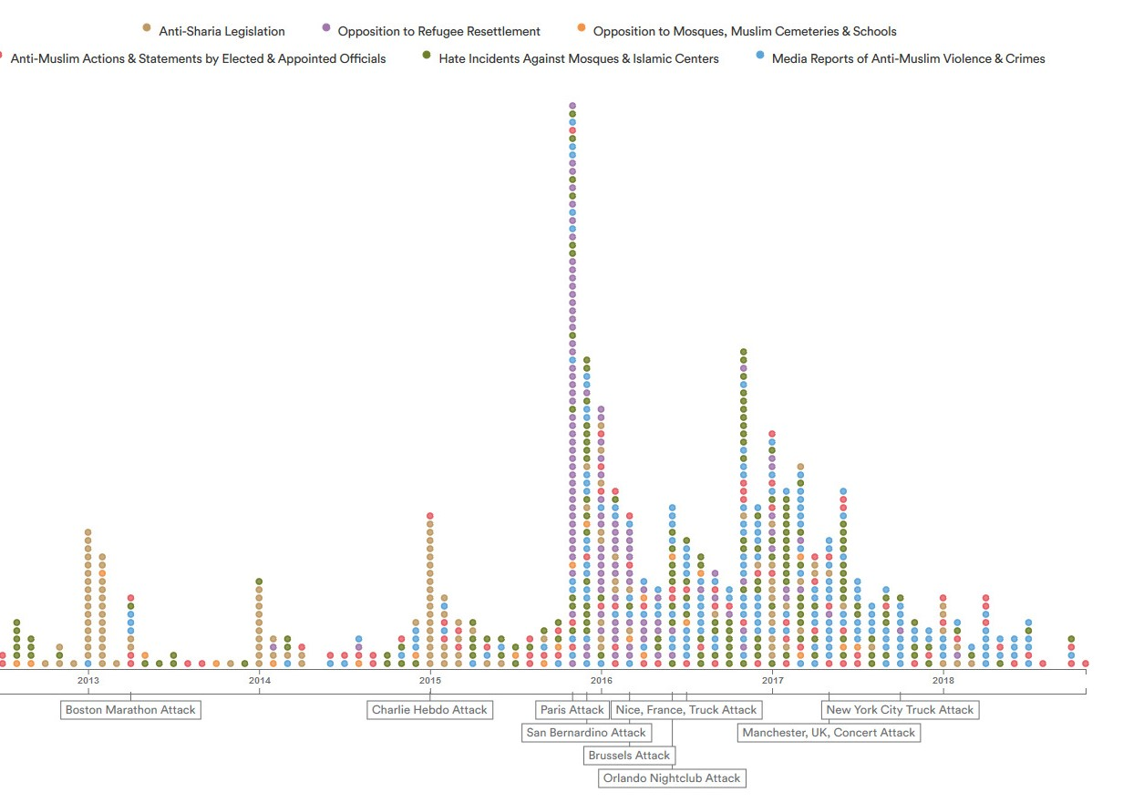
Figure 2
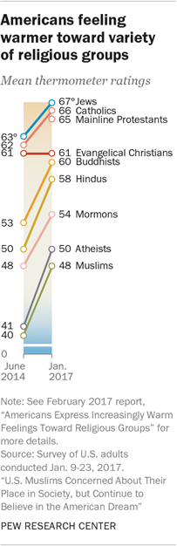
Figure 3
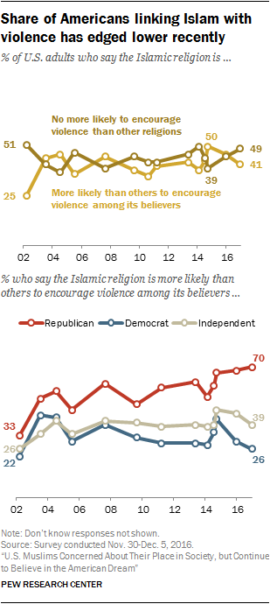
Figure 4
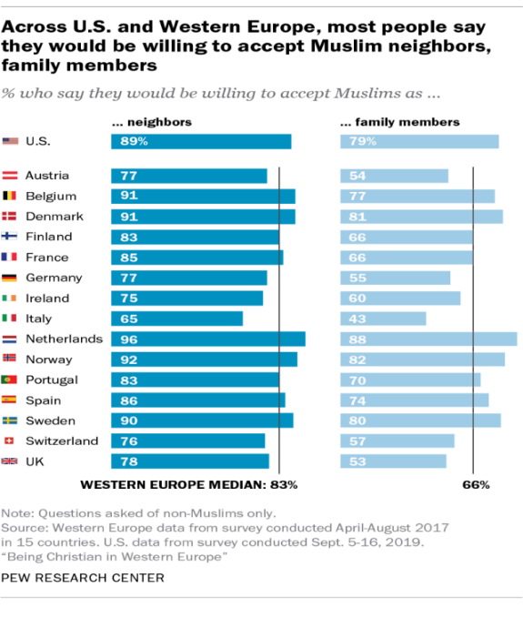
Figure 5
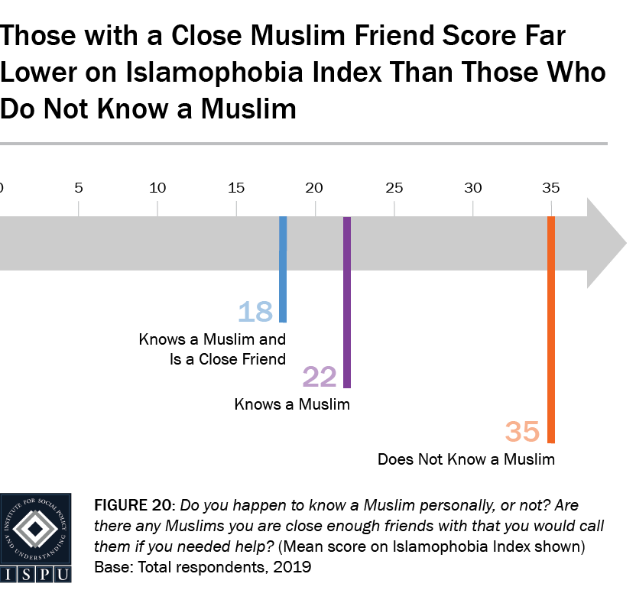

Figure 6
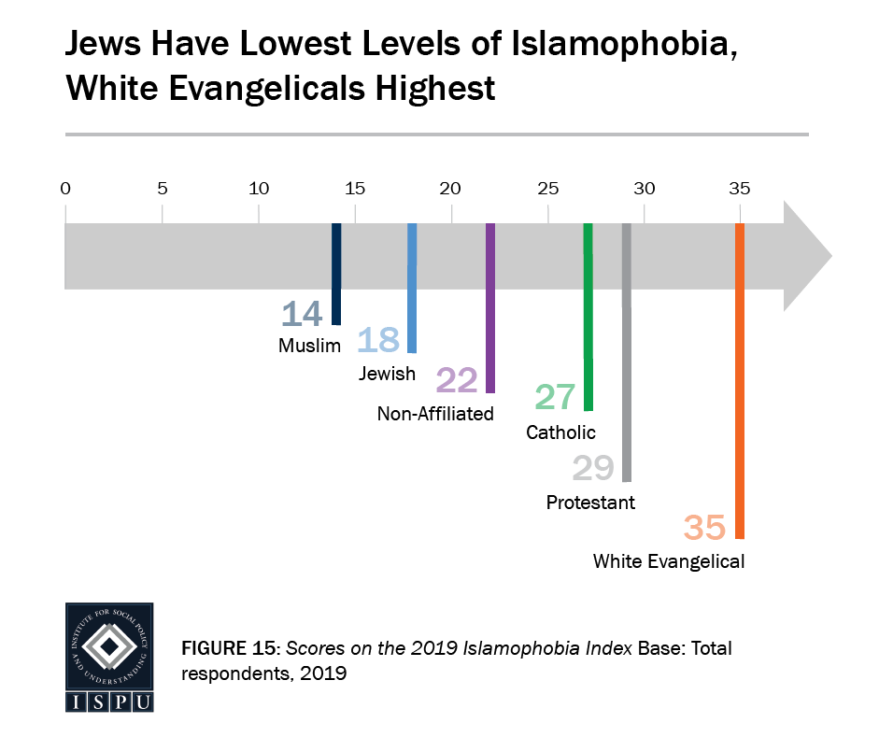
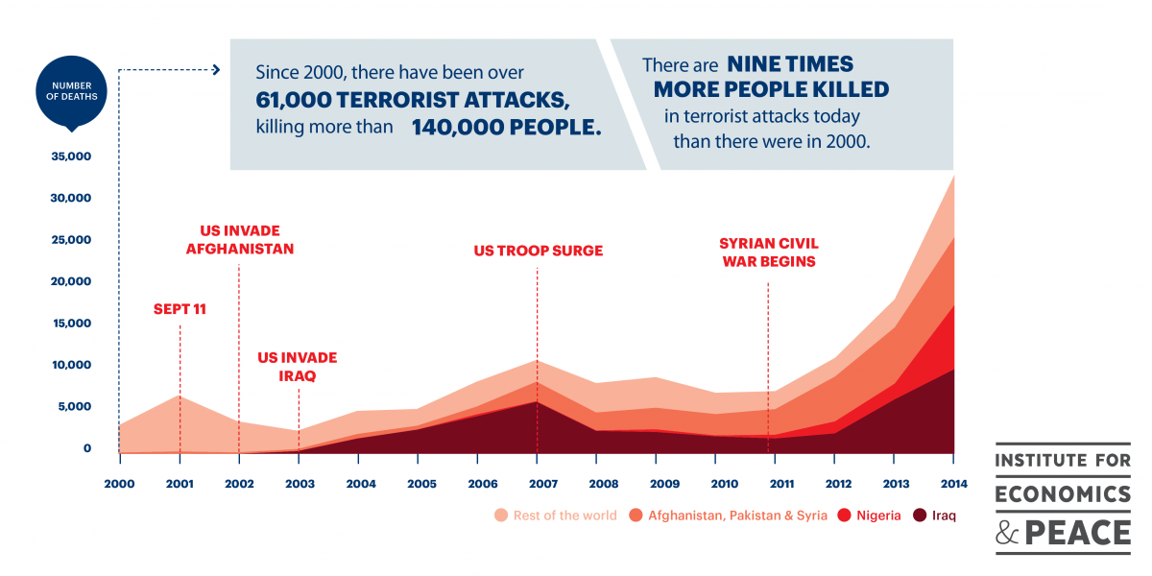
Figure 7

Figure 8
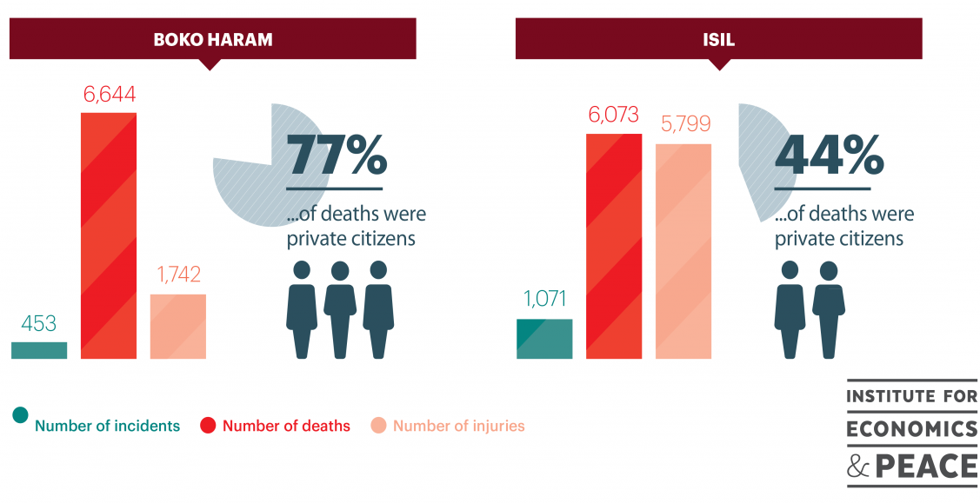

Figure 9
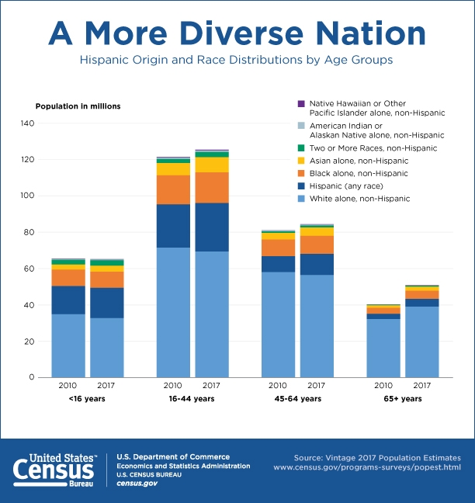

Khaled A. Beydoun, American Islamophobia: Understanding the Roots and Rise of Fear (Oakland: University of California, 2018), p 27
Ibid.
Ibid., p 28
Ibid., p 92
Ibid.
The intercept, “How Islamophobia Was Ingrained in America's Legal System Long Before the War on Terror,” The Intercept, May 6, 2018, https://theintercept.com/2018/05/06/american-islamophobia-khaled-beydoun-interview/)
Ibid.
Ibid.
Ibid.
Beydoun, p 37
Ibid., p 53
Ibid., pp 29, 31
Ibid.
Ibid., p 31
“Good Muslim, Bad Muslim: A Political Perspective on ...,” accessed November 11, 2019, http://jan.ucc.nau.edu/sj6/mamdanigoodmuslimbadmuslim.pdf), p 773
“Terrorism,” Merriam-Webster (Merriam-Webster), accessed December 9, 2019, https://www.merriam-webster.com/dictionary/terrorism)
“Terrorism,” FBI, (FBI, May 3, 2016), https://www.fbi.gov/investigate/terrorism. See also Hauser Global Law School Program, which defines terrorism as: (a) A threat or act of violence against a person or property; (b) Intention or motive to intimidate a population; (c) It must create a state of terror among the population; (d) It must threaten international security. Defining International Terrorism in Light of Liberation Movements-GlobaLex, accessed November 18, 2019, https://www.nyulawglobal.org/globalex/International_terrorism_liberation_movements.html)
Ibid.
“Terrorism,” FBI, (FBI, May 3, 2016), https://www.fbi.gov/investigate/terrorism.
Ibid.
Ibid.
What is the USA Patriot Web, accessed December 10, 2019, https://www.justice.gov/archive/ll/highlights.htm)
Ibid.
“National Commission on Terrorist Attacks Upon the United States,” The University of Warwick, Barbara A. Grewe, accessed October 5, 2019, https://warwick.ac.uk/fac/soc/pais/people/aldrich/vigilant/wall.pdf)
Ibid.
Ibid.
Author’s phone conversation with Dr. Jacob Ari Labendz, Friday November 15, 2019. Dr. Labendz is a Clayman Assistant Professor of Judaic and Holocaust Studies, Director of the Center for Judaic and Holocaust Studies, Department of History, Youngstown State University. Jewish Veganism and Vegetarianism (co-edited with Shmuly Yanklowitz): https://bit.ly/2Wgjzqd, and Jewish Property after 1945 (contributing editor): http://bit.ly/2ybGiaJ.
The intercept, “How Islamophobia Was Ingrained in America's Legal System Long Before the War on Terror,” The Intercept, May 6, 2018, https://theintercept.com/2018/05/06/american-islamophobia-khaled-beydoun-interview/)
Ibid.
“Islamophobia and Racism in America by Erik Love,” Goodreads (Goodreads, May 23, 2017), https://www.goodreads.com/book/show/32561224-islamophobia-and-racism-in-america
Ibid.
Beirut Marine Barracks Bombing, Fast Facts, CNN, www.cnn.com/2013/06/13/world/meast/beirut-marine-barracks-bombing-fast-facts/index.html)
Bernard, Lewis, "The Roots of Muslim Rage," The Atlantic Monthly (September 1990), www.theatlantic.com/magazine/archive/1990/09/the-roots-of-muslim-rage/304643/
Ibid.
Fred Halliday, “'Islamophobia' Reconsidered,” Taylor & Francis, 2000, p898-899, accessed November 14, 2019, https://www.tandfonline.com/doi/abs/10.1080/014198799329305)
Ibid.
Ibid.
Sophia Rosenbaum, “Professor says Jews are behind 9/11 attacks and she's keeping her job,” New York Post, (October 2000), https://nypost.com/2016/03/02/oberlin-college-president-stands-by-anti-semitic-professor/
Vanessa M. Gezari, “The Secret Alliance,” The New Republic, August 19, 2011, https://newrepublic.com/article/92775/taliban-conspiracy-theory)
Fawaz Turki, “Conspiracy Theories in Arab Discourse,” Arab News, October 18, 2001, https://www.arabnews.com/node/215565)
“Full Text: Bin Laden's 'Letter to America',” The Guardian (Guardian News and Media, November 24, 2002), https://www.theguardian.com/world/2002/nov/24/theobserver)
Beydoun, p 31
“How the U.S. General Public Views Muslims and Islam,” Pew Research Center's Religion & Public Life Project, July 26, 2017, https://www.pewforum.org/2017/07/26/how-the-u-s-general-public-views-muslims-and-islam/)
Ibid.
Ibid.
Beydoun, p 31
Josh Sanburn, “U.S. Population Diversity Census Report,” Time (Time, June 25, 2015), https://time.com/3934092/us-population-diversity-census/)
US Census Bureau, “A More Diverse Nation,” The United States Census Bureau, October 1, 2018, https://www.census.gov/library/visualizations/2018/comm/diverse-nation.html)
Sameen Tahir Khan, “Most of the Americans Are Not Islamophobes,” Arab News (Arabnews, December 21, 2015), http://www.arabnews.com/world/news/853771)
Ibid.
Ibid.
Ibid.
Ibid.
“How the U.S. General Public Views Muslims and Islam,” Pew Research Center's Religion & Public Life Project, July 26, 2017, https://www.pewforum.org/2017/07/26/how-the-u-s-general-public-views-muslims-and-islam/)
Ibid.
Ibid.
“Across U.S. and Western Europe, Most People Say They Would Be Willing to Accept Muslim Neighbors, Family Members,” Pew Research Center (Pew Research Center, October 8, 2019), https://www.pewresearch.org/fact-tank/2019/10/08/in-the-u-s-and-western-europe-people-say-they-accept-muslims-but-opinions-are-divided-on-islam/ft_19-10-07_viewsmuslimseurope_neighborsfamily420px/)
“American Muslim Poll 2019: Predicting and Preventing Islamophobia: ISPU,” Institute for Social Policy and Understanding, September 12, 2019, https://www.ispu.org/american-muslim-poll-2019-predicting-and-preventing-islamophobia/)
Ibid.
“Anti-Muslim Activities in the United States,” accessed October 17, 2019, New America, https://www.newamerica.org/in-depth/anti-muslim-activity/
The intercept, “How Islamophobia Was Ingrained in America's Legal System Long Before the War on Terror,” The Intercept, May 6, 2018, https://theintercept.com/2018/05/06/american-islamophobia-khaled-beydoun-interview/)
Ibid.
Ibid.
“MRC Study: ABC, CBS and NBC Tilt Ground Zero Mosque Debate by Smearing Americans as 'Islamophobic',” NewsBusters, accessed December 10, 2019, https://www.newsbusters.org/blogs/nb/rich-noyes/2010/09/15/mrc-study-abc-cbs-and-nbc-tilt-ground-zero-mosque-debate-smearing)
Jason Burke, “The Media under-Reports Threat of Islamic Terrorism – to Muslims,” The Guardian (Guardian News and Media, February 7, 2017), https://www.theguardian.com/us-news/2017/feb/07/media-under-reports-threat-islamic-terrorism-to-muslims-trump-white-house-list)
Ibid.
Svati Kirsten Narula, “More People Died from Terrorism Last Year than Ever before-and Mostly in These Five Countries,” Quartz (Quartz, November 18, 2015), https://qz.com/552334/more-people-died-from-terrorism-last-year-than-ever-before-and-mostly-in-these-five-countries/)
Ibid.
Ibid.
“US Court Says Trump Travel Ban Unlawfully Discriminates against Muslims,” CNBC (CNBC, February 15, 2018), https://www.cnbc.com/2018/02/15/us-court-says-trump-travel-ban-unlawfully-discriminates-against-muslims.html)
“Driven by the Curiosity to Explore,” Saudi Aramco, accessed December 9, 2019, https://www.saudiaramco.com/en/who-we-are/overview/our-history)
“Saudi Aramco World : Prelude to Discovery,” AramcoWorld, accessed December 9, 2019, https://archive.aramcoworld.com/issue/199901/prelude.to.discovery.htm)
U.S. Department of State (U.S. Department of State), accessed December 9, 2019, https://2001-2009.state.gov/r/pa/ho/time/lw/97179.htm)
“Operation Desert Storm,” ushistory.org (Independence Hall Association), accessed December 11, 2019, https://www.ushistory.org/us/60a.asp)
Andrew Shryock, “‘Introduction: Islam as an Object of Fear and Affection," in Islamophobia/Islamophilia: Beyond the Politics of Enemy and Friend. Andrew Shryock, Ed. Pp. 1-25. Bloomington: Indiana University Press,” Academia.edu, accessed November 21, 2019.
Ibid.
Ibid.
Ibid.
Halliday, p 899
Ibid.
Mamdani, p 766
Ibid.
Ibid., p767
“The World,” Public Radio International, November 11, 2019, https://www.pri.org/stories/2016-08-17/us-has-most-islamic-government-world-says-one-american-muslim.
Ibid.
Ibid.
Mossab Hassan Youssef and Ron Brackin, Son of Hamas A Gripping Account of Terror, Betrayal, Political Intrigue, and Unthinkable Choices (Stream, IL: Tyndale House Publishers, 2014), p 5-8.
Greg Myre, “From Threats Against Salman Rushdie To Attacks On 'Charlie Hebdo',” NPR (NPR, January 8, 2015), https://www.npr.org/sections/parallels/2015/01/08/375662895/from-threats-against-salman-rushdie-to-attacks-on-charlie-hebdo)
https://www.salmanrushdie.com/the-satanic-verses/)
Greg Myre, “From Threats Against Salman Rushdie To Attacks On 'Charlie Hebdo',” NPR (NPR, January 8, 2015), https://www.npr.org/sections/parallels/2015/01/08/375662895/from-threats-against-salman-rushdie-to-attacks-on-charlie-hebdo)
According to Oxford Islamic Studies, Jihad has many definitions or meanings. “From the Arabic root meaning “to strive,” “to exert,” “to fight”; exact meaning depends on context.” It may “express a struggle against one's evil inclinations, an exertion to convert unbelievers, or a struggle for the moral betterment of the Islamic community.” For instance, “without any religious connotation, with a meaning more or less equivalent to the English word crusade (as in “a crusade against drugs”).” However, if it is ”used in a religious context, the adjective Islamic or holy is added. Furthermore, Jihad is the only legal warfare in Islam, and it is carefully controlled in Islamic law,” and it “must be called by a duly constituted state authority, it must be preceded by a call to Islam or treaty, noncombatants must not be attacked, and so on. To justify the struggle against their coreligionists, extremists branded them unbelievers for their neglect in adhering to and enforcing a particular interpretation of Islam.” Moreover, “Contemporary thinking about jihad offers a wide spectrum of views, including conservatives who look to classical Islamic law on the subject and radicals who promote a violent jihad against Muslim and non-Muslim rulers.” “Jihad.” Oxford Islamic Studies Online. Accessed November 18, 2019. http://www.oxfordislamicstudies.com/article/opr/t125/e1199.

